Lab 3: Authentication Vulnerabilities (password-based)
Objective:
- In this section, we'll look more closely at some of the most common vulnerabilities that occur in password-based login mechanisms. We'll also suggest ways that these can potentially be exploited.
In this lab, students need to:
- Perform two challenges:
  - Username enumeration via different responses
  - Username enumeration via response timing
- Explain and capture all steps (full windows screen capture).

Submit a report addressing all the questions mentioned above in either PDF or Markdown format. Additionally, include a video demonstrating the detailed process of your work to ensure the authenticity of your lab exercise.
The report file name must be Class_YourStudentID _YourName_Lab3
1. Username enumeration via different responses
Login requests are captured using Burp Suite to analyze how the server responds to different usernames. Differences in responses can reveal valid usernames, leading to a username enumeration vulnerability.
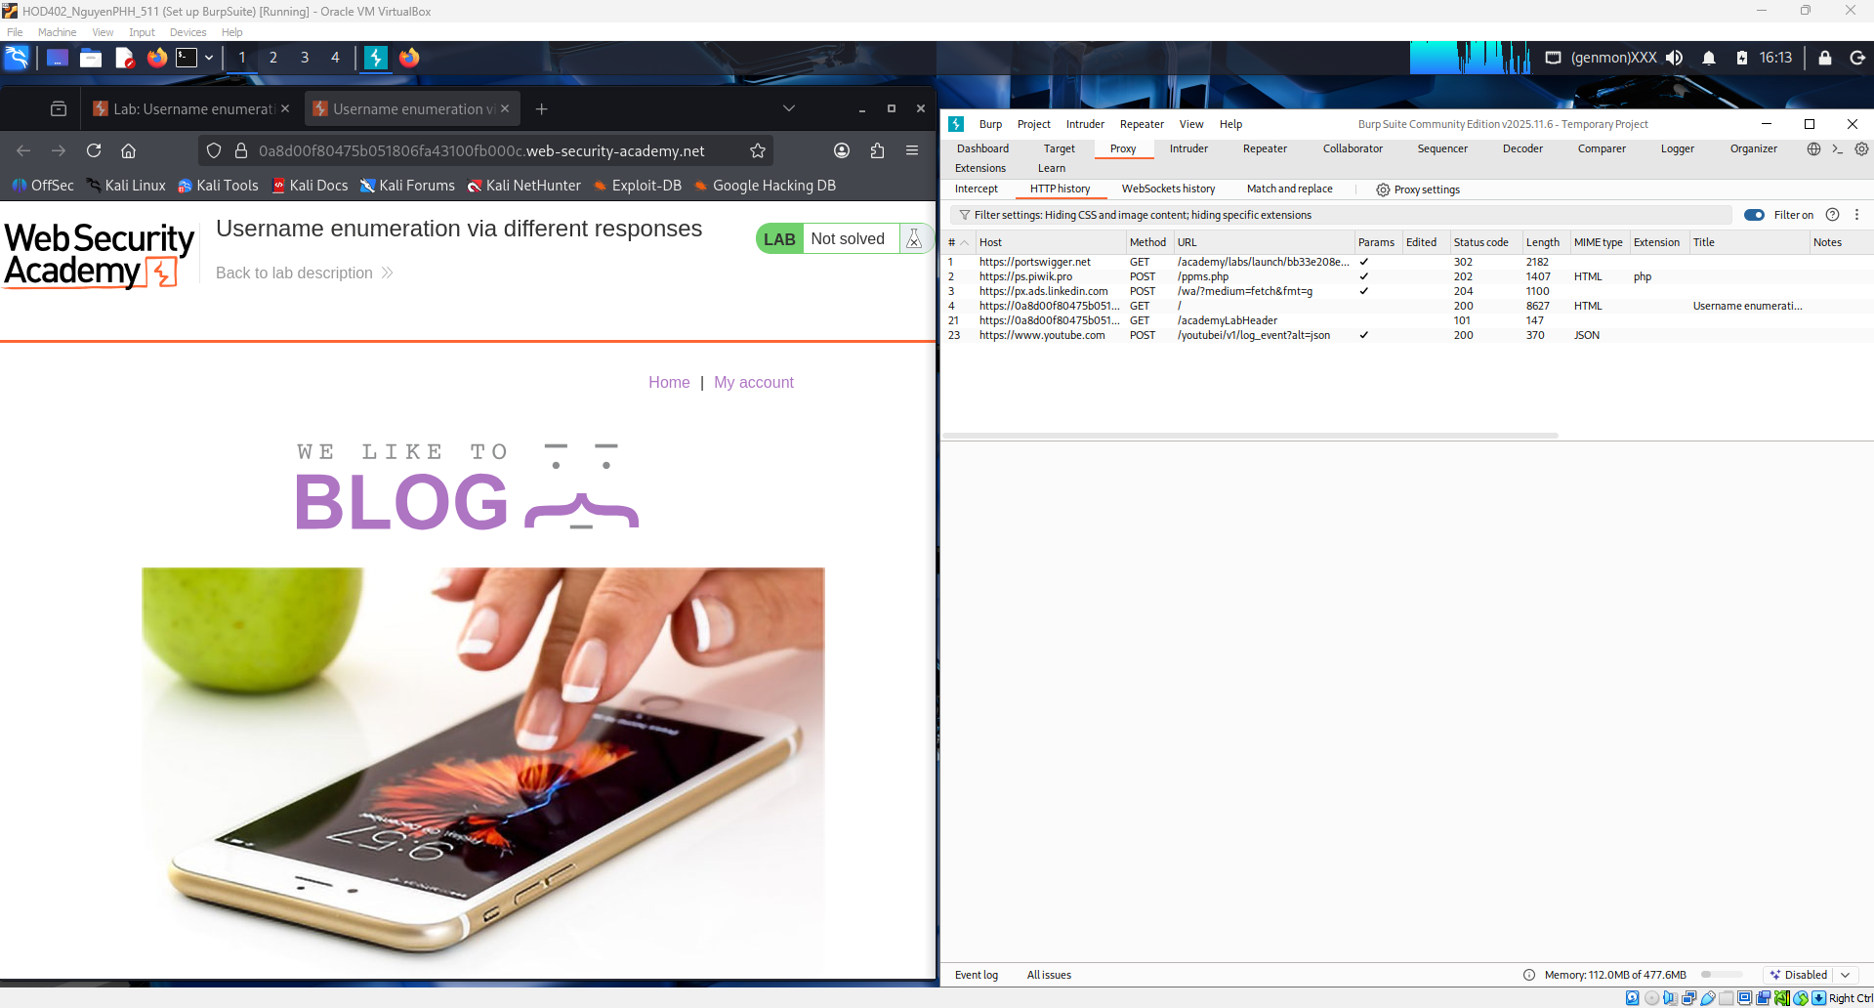
The login page displays an “Invalid username” error message when an incorrect username is submitted. By capturing the login request in Burp Suite, attackers can identify valid usernames based on different server responses.
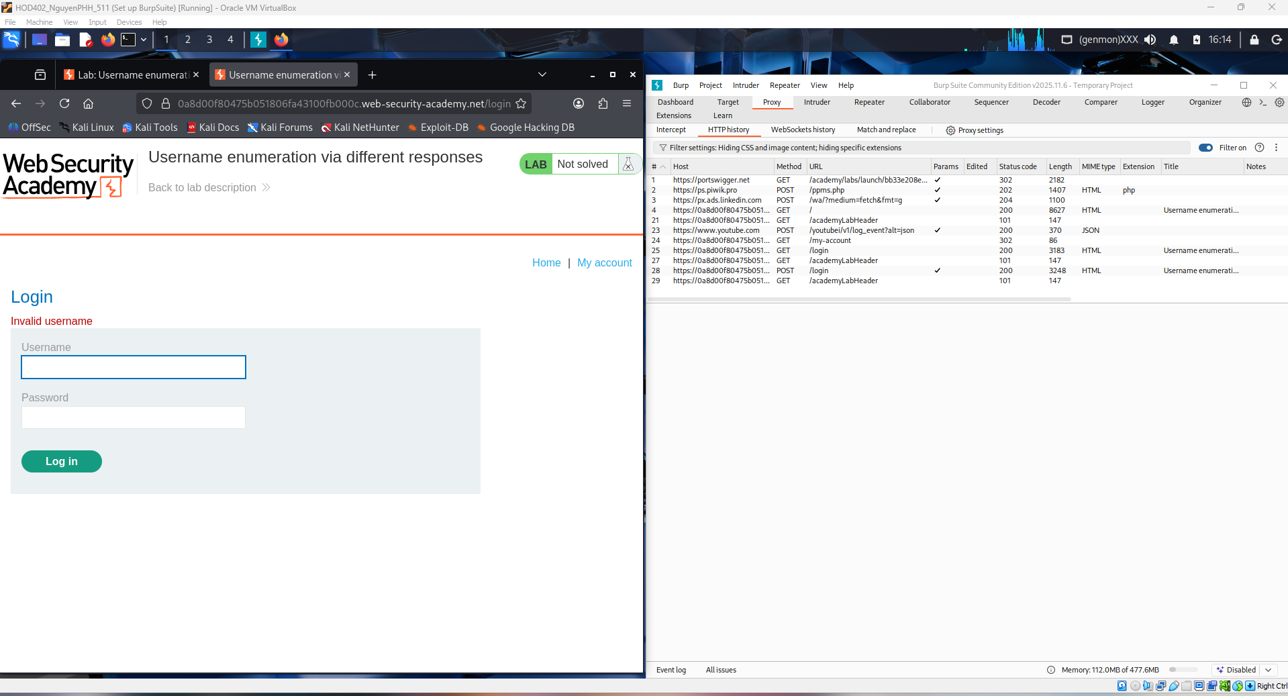

Burp Suite captures the POST /login request containing username and password parameters. By modifying the username value and observing server responses, it is possible to determine whether a username exists in the system.
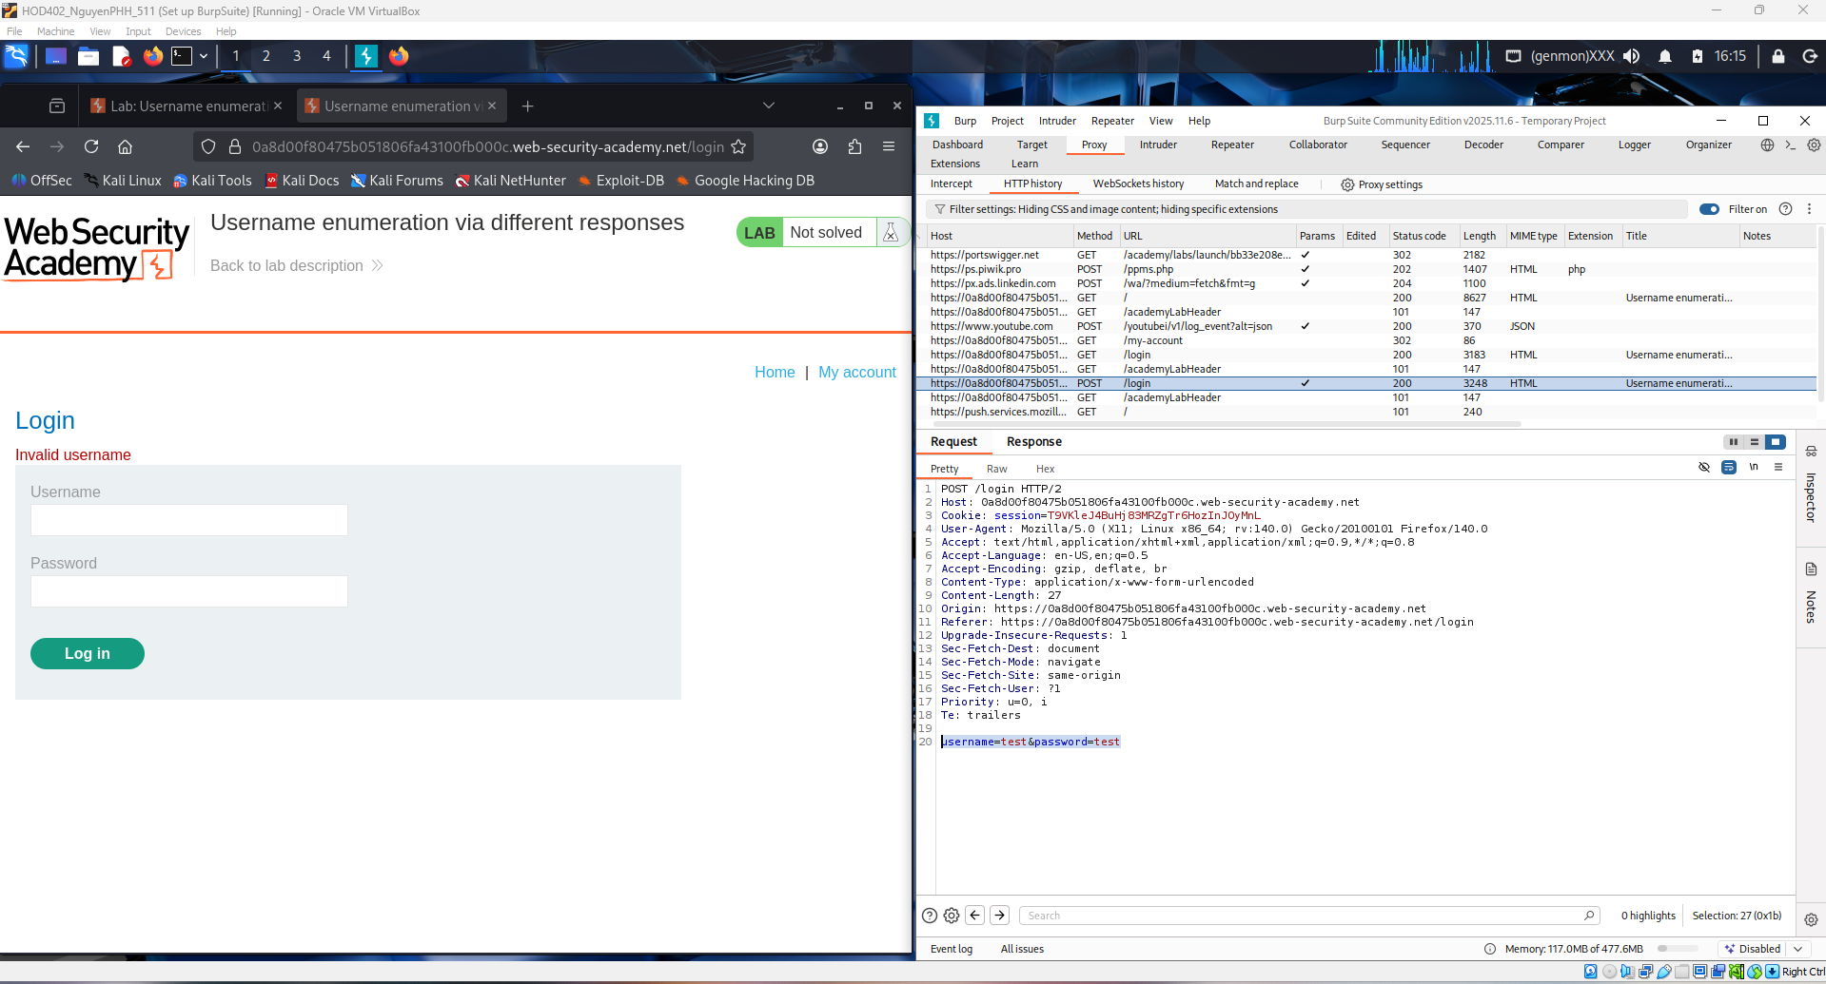
The captured POST /login request is sent to Burp Intruder for automated testing. The username parameter is marked as a payload position and multiple usernames are injected into the request. By analyzing differences in server responses, such as error messages or response lengths, valid usernames can be identified.
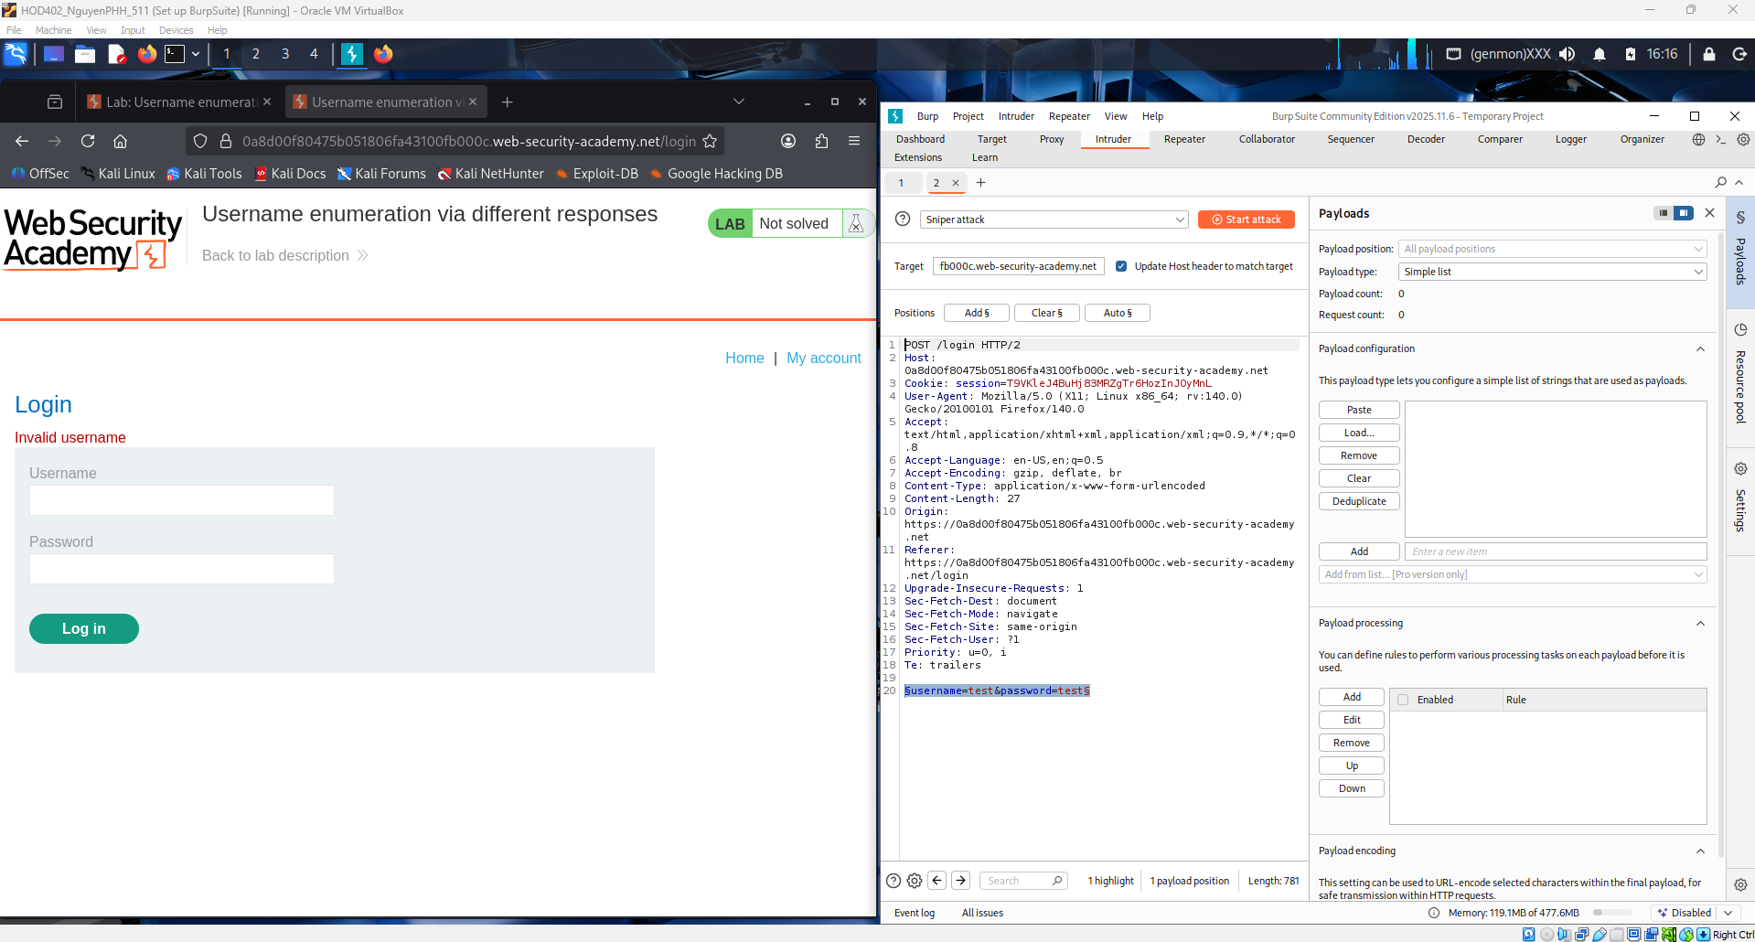

A predefined list of common usernames is obtained from the PortSwigger Authentication lab. This list is loaded into Burp Intruder as payloads to automate login attempts. Differences in server responses are then analyzed to identify valid usernames.
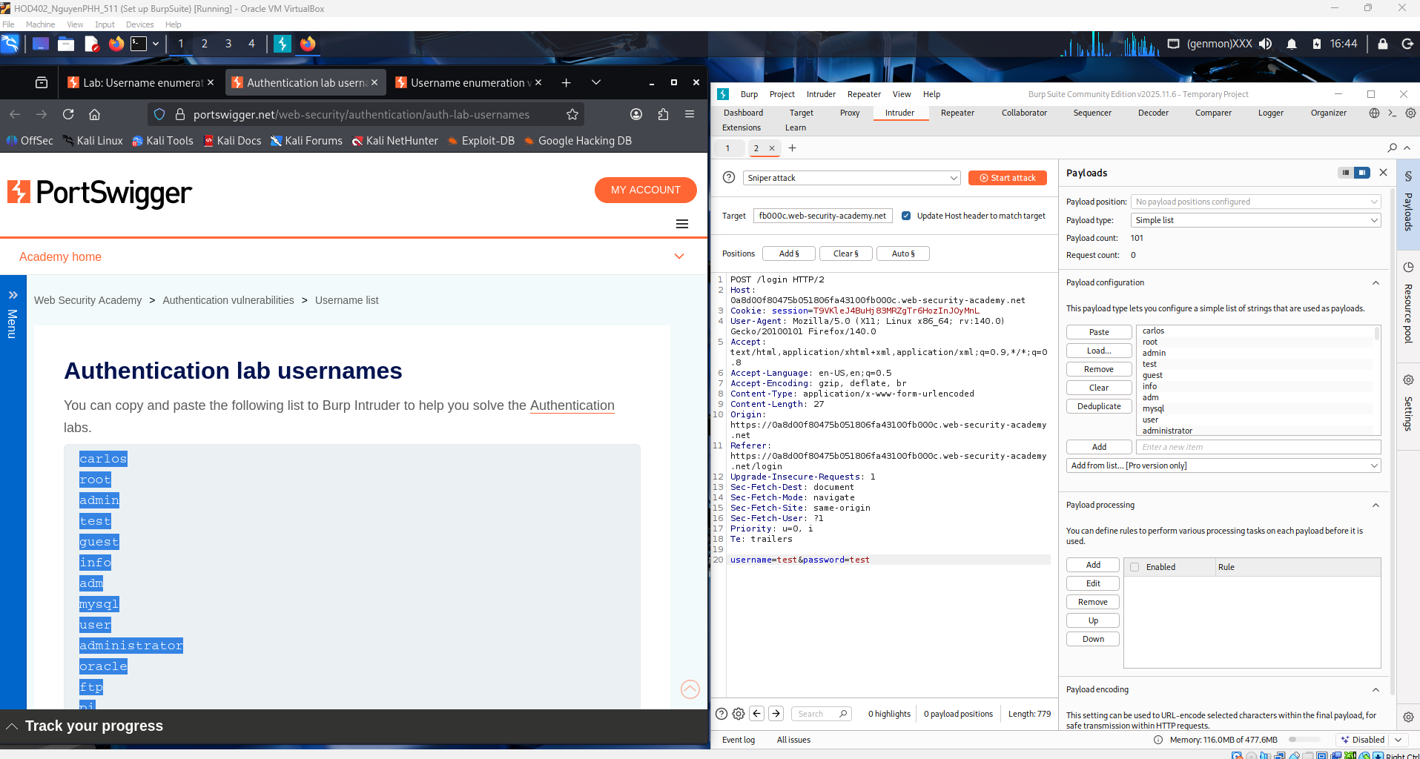
Burp Intruder results show different response lengths when testing multiple usernames. While most usernames return identical responses, one username produces a different response length, indicating a valid account. This confirms the presence of a username enumeration vulnerability.
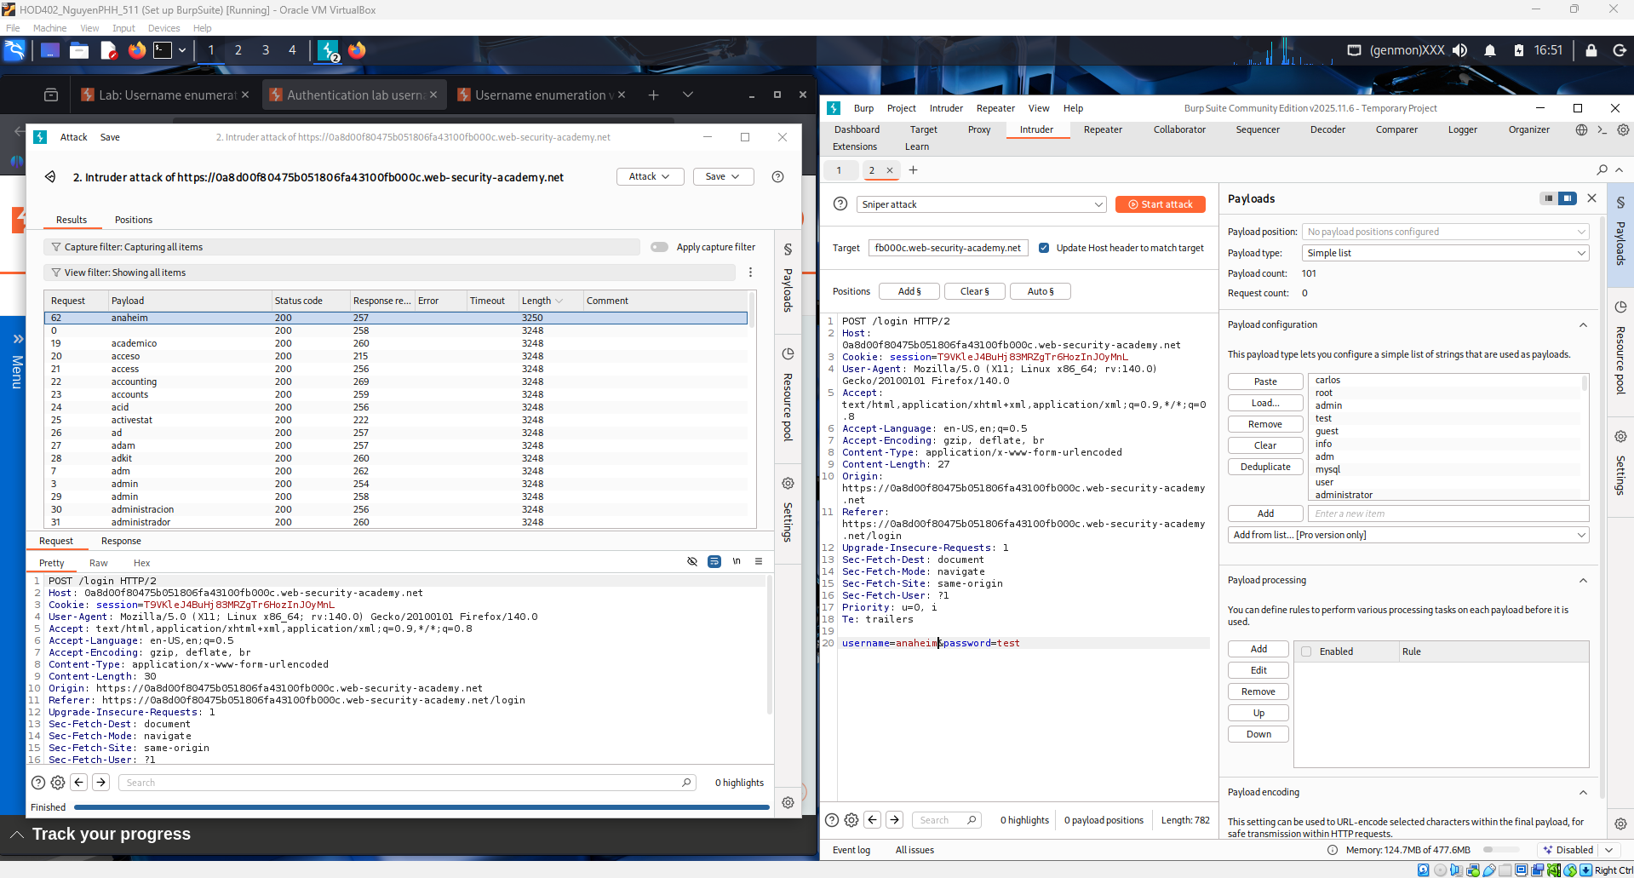

A predefined list of common passwords is loaded into Burp Intruder. The previously identified valid username is used with multiple password attempts. By analyzing the server responses, the correct password can be identified, leading to a successful login.
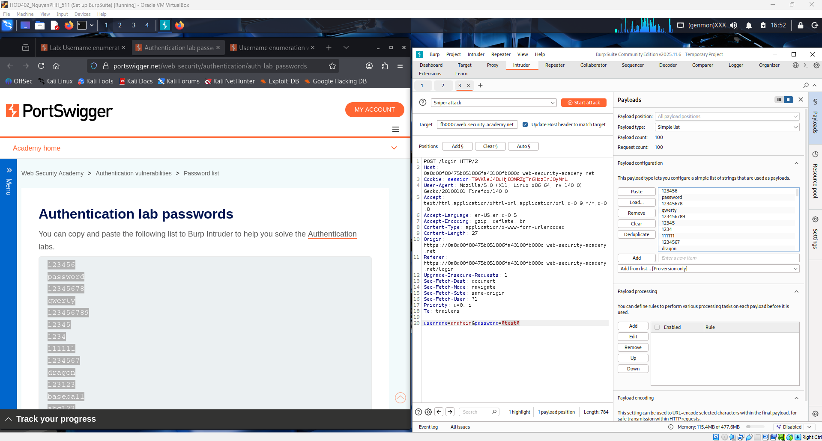
Burp Intruder results show a different response when the correct password is used. While most attempts return normal error responses, one request returns a 302 redirect, indicating a successful login. This confirms that the valid credentials have been identified.
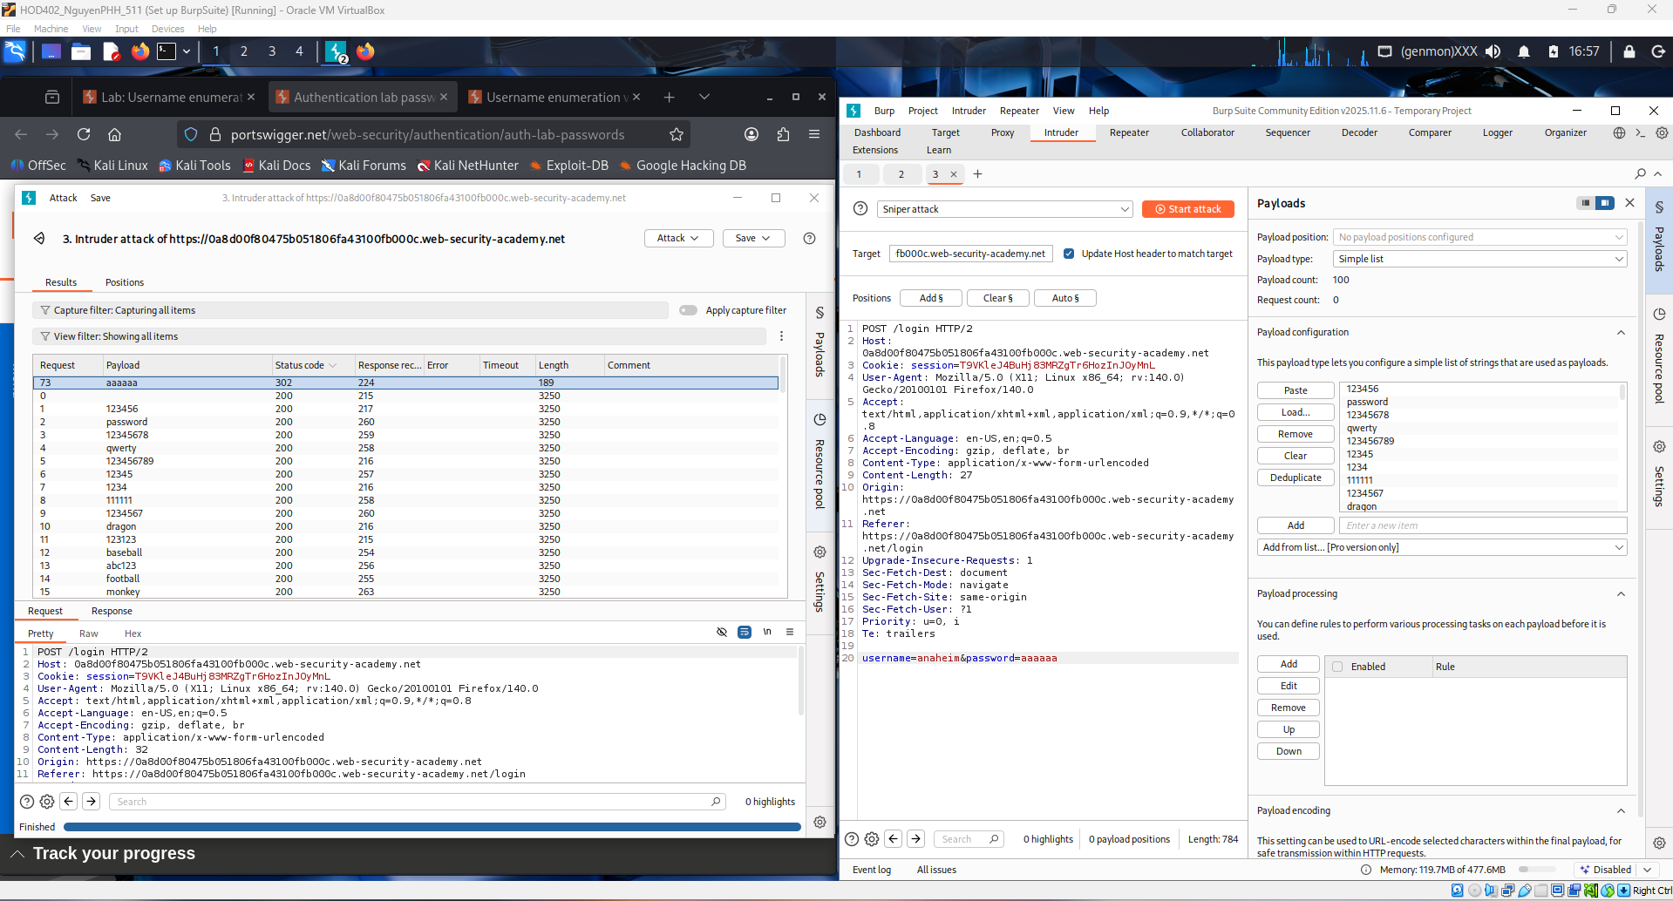

The lab is successfully solved after identifying a valid username and password. The successful login confirms that the application is vulnerable to username enumeration through different server responses. This demonstrates an authentication vulnerability in the login mechanism.
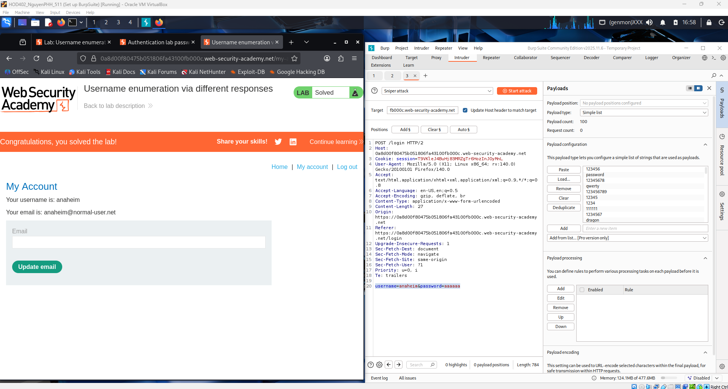
Conclusion
In this lab, username enumeration vulnerabilities were successfully identified and exploited. By analyzing different server responses during the login process, a valid username was discovered. Using this information, a password attack was performed, leading to a successful login.
This lab demonstrates that inconsistent error messages and response behaviors can allow attackers to enumerate valid usernames and compromise authentication mechanisms. Proper input handling and uniform error responses are essential to prevent such vulnerabilities.

2. Username enumeration via response timing
This screenshot shows the Web Security Academy login page being tested while Burp Suite is running in the background to capture HTTP traffic. The attacker submits a login request with a username and monitors the server’s response time to detect differences between valid and invalid usernames. Variations in response length/time in Burp Proxy (HTTP history) indicate possible username enumeration based on timing behavior.
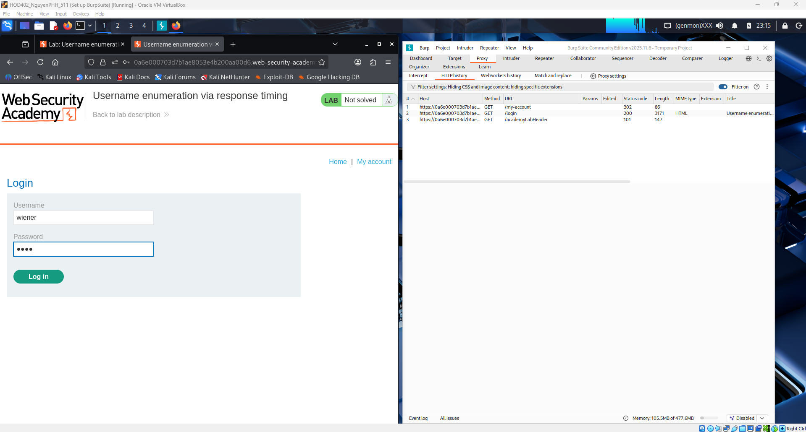
Shows a failed login attempt on the Web Security Academy lab page, returning the message “Invalid username or password.” At the same time, Burp Suite Proxy captures the POST /login request containing the parameters username and password. This request will later be sent to Burp Intruder to test multiple usernames and observe differences in server response time for enumeration.
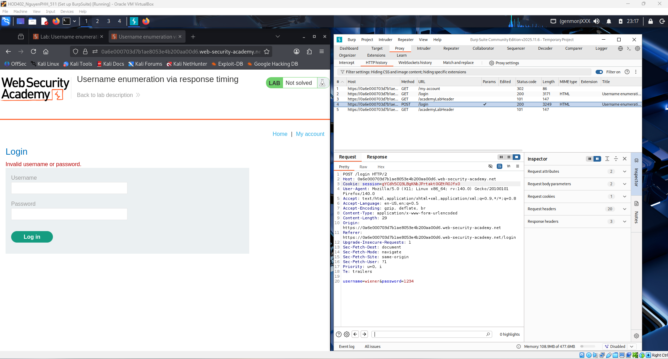
Shows the captured POST /login request being tested in Burp Repeater. The request includes the parameters username=wiener and password=1234, and the server responds with an error message (“Missing parameter”), confirming the structure of the login request. Repeater is used here to manually resend and analyze server responses before automating timing attacks in Intruder.
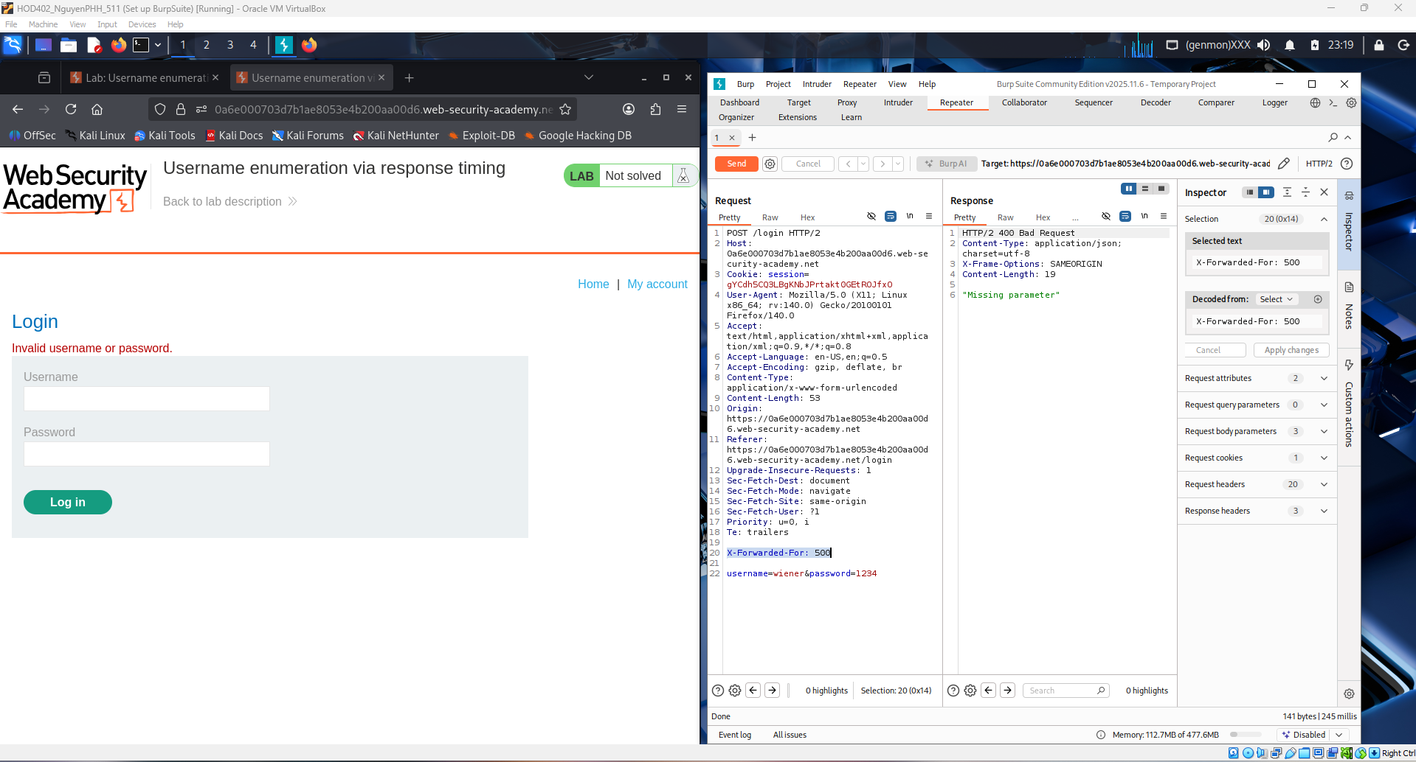
This screenshot shows the login request being modified in Burp Repeater. The header X-Forwarded-For is added/changed, and the parameters username=wiener and password=1234 are visible, allowing the tester to resend requests and observe how the server responds. This step helps confirm how the application processes login attempts before automating multiple username tests to measure response time differences.
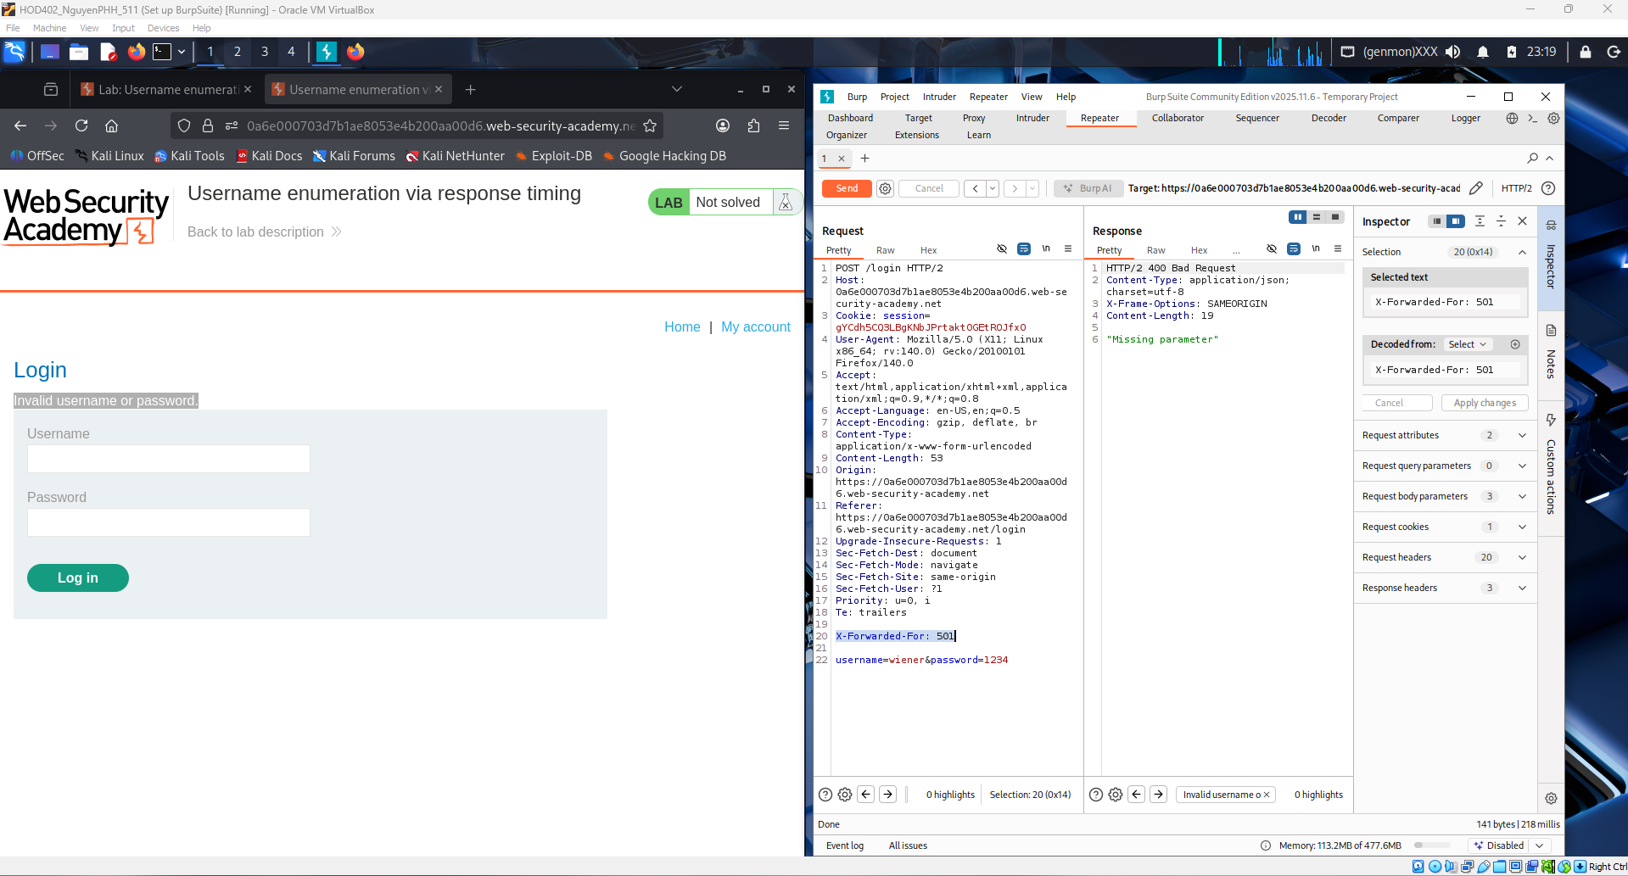
Shows the server’s HTML response in Burp Repeater after a failed login attempt. The response contains the message “Invalid username or password”, confirming how the application handles incorrect credentials. This helps establish a baseline response so later differences in response time (not content) can be used to distinguish valid usernames during enumeration.
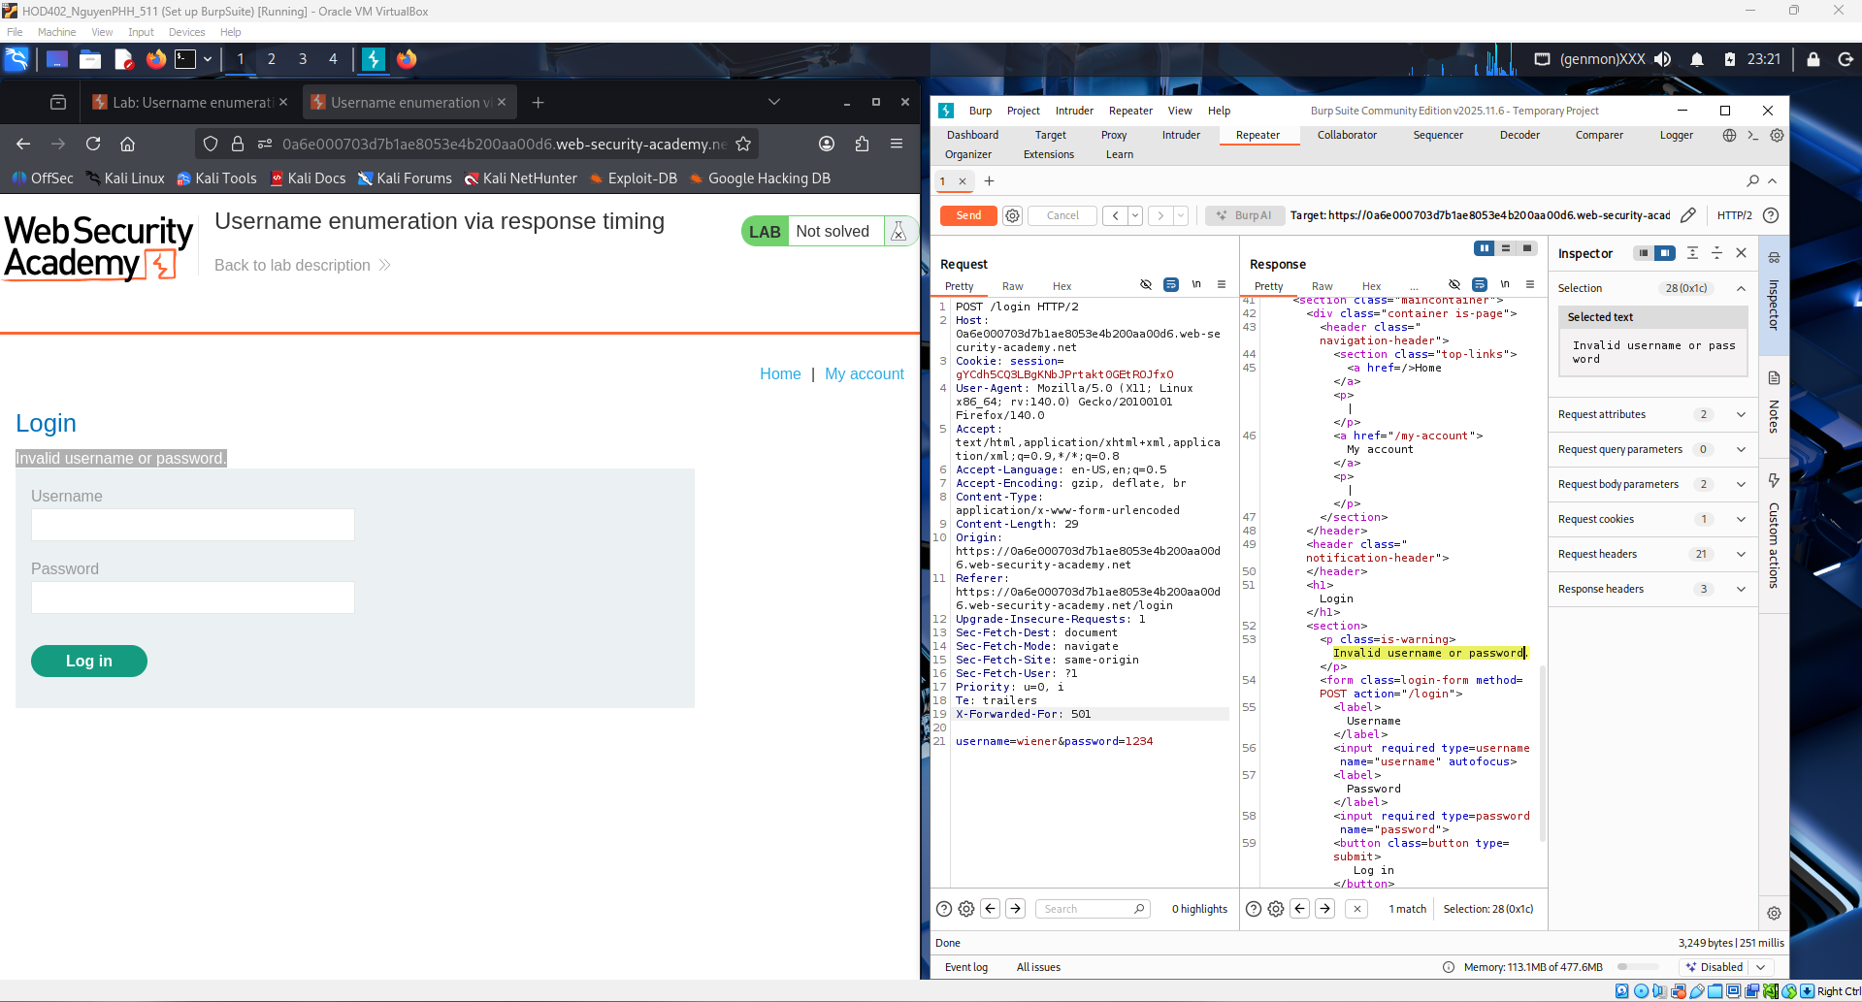
Shows the normal HTML response from the server after a failed login attempt, displayed in Burp Repeater. The message still indicates an invalid login, meaning the content of the response does not change between usernames. Because the response body is consistent, the attack in this lab relies on measuring response time differences instead of analyzing response text.
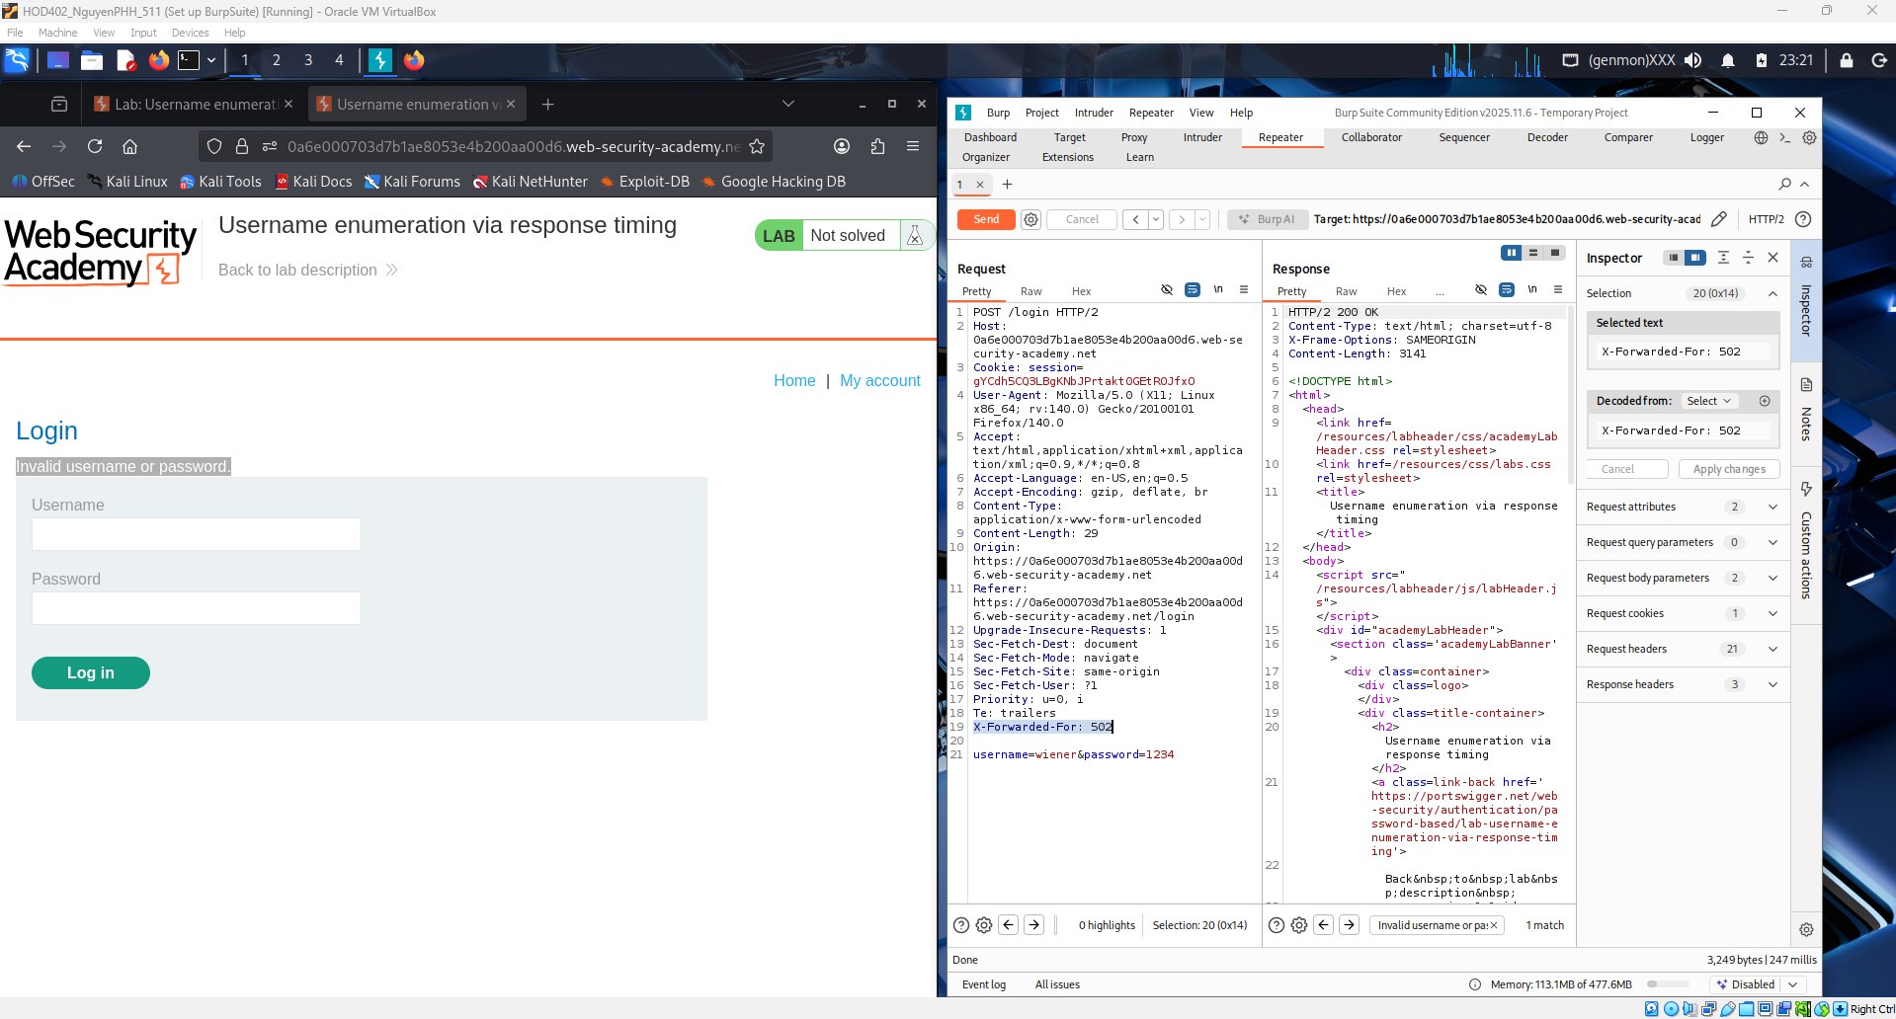
Shows another failed login attempt analyzed in Burp Repeater, where the server response again contains the message “Invalid username or password.” The repeated identical response confirms that the application does not reveal username validity through content differences. Therefore, attackers must rely on response time variations to identify valid usernames in this lab.
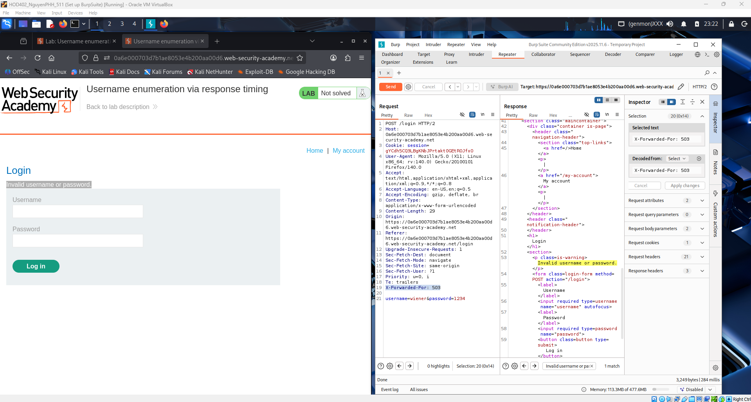
Shows another login attempt sent through Burp Repeater with the same parameters. The server response again includes the error message “Invalid username or password”, and the page structure remains unchanged. This confirms that response content is consistent, so attackers must rely solely on response time measurement to perform username enumeration.
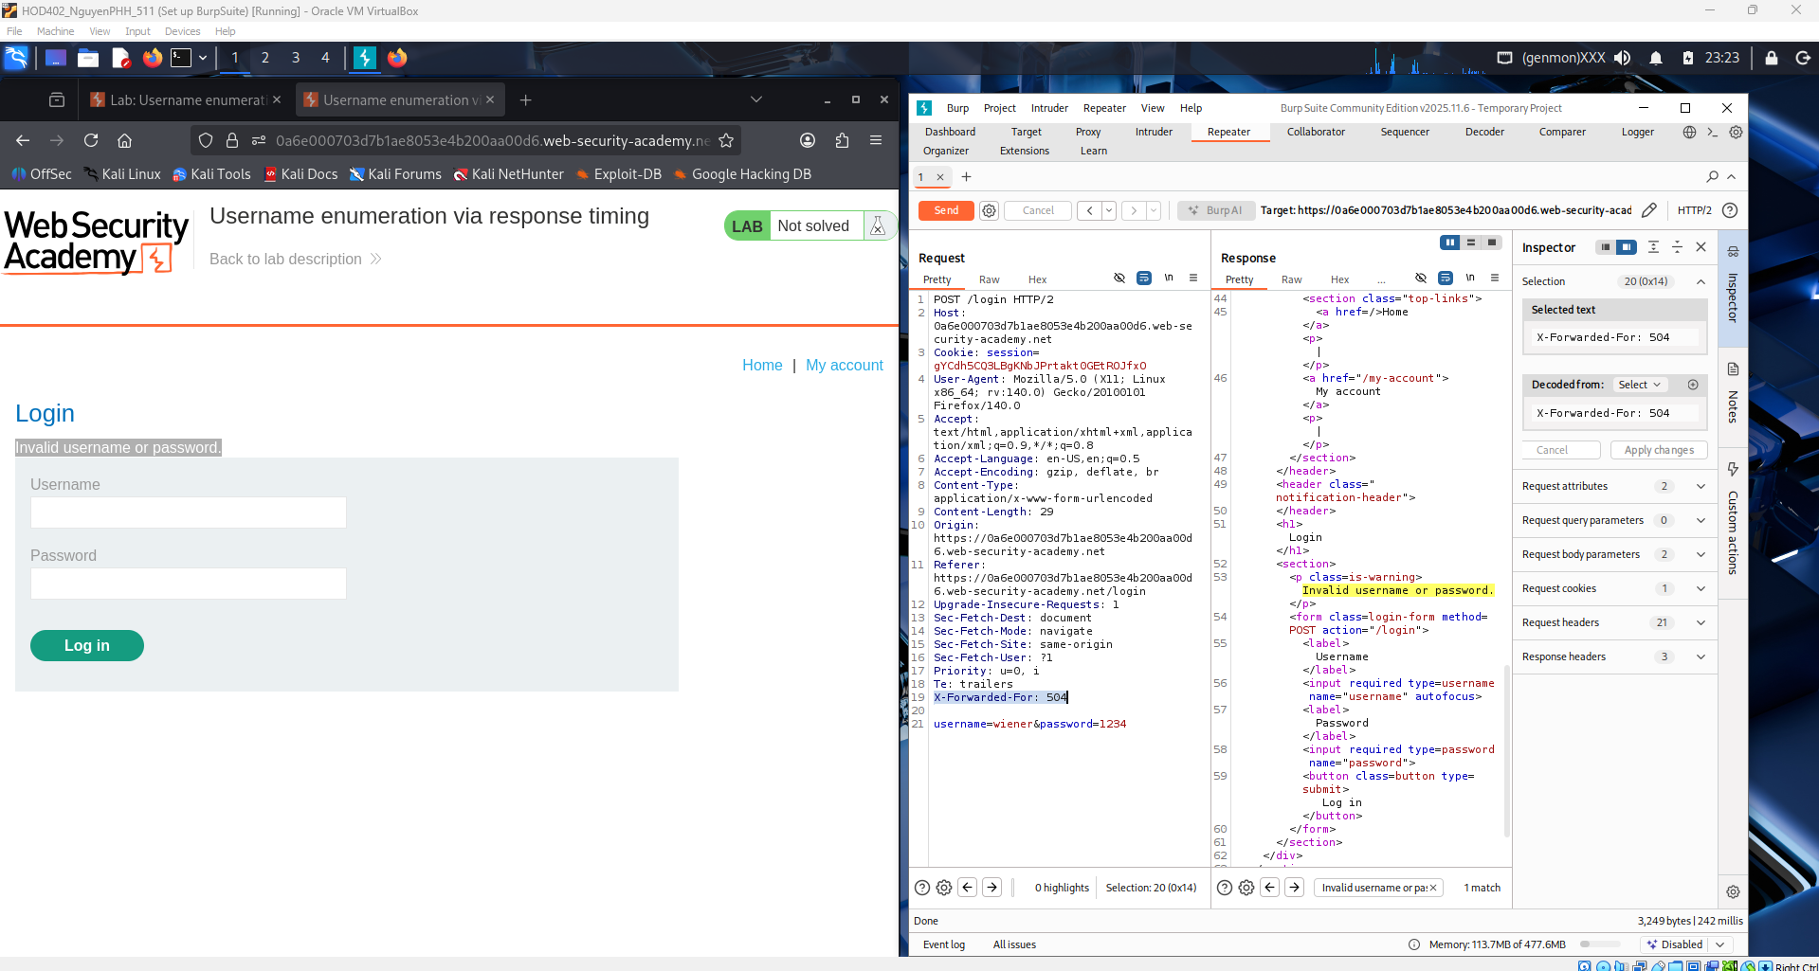
Shows a login request sent in Burp Repeater where the server response is now HTTP/1.1 302 Found instead of returning the usual error page. The response includes a Location header and sets a session cookie, indicating the server processed the username differently. This change suggests the username exists, and the delay in password verification is what enables username enumeration via response timing.
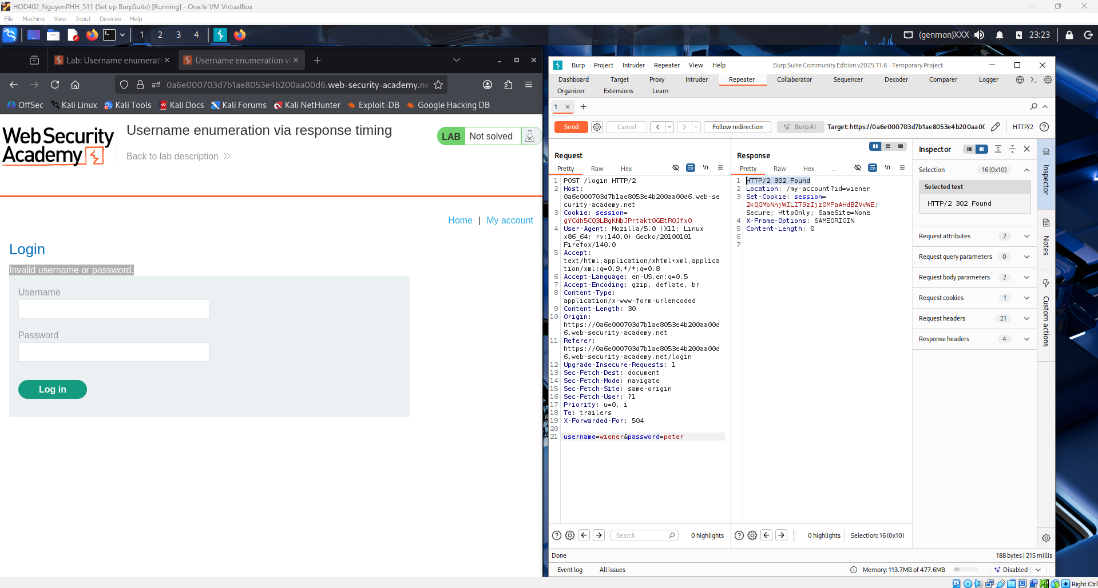
Shows a login request in Burp Repeater where the password parameter contains a very long string. The server still returns the message “Invalid username or password”, but processing a long password increases the time taken when the username is valid. This artificial delay helps attackers distinguish valid usernames by measuring response time differences.
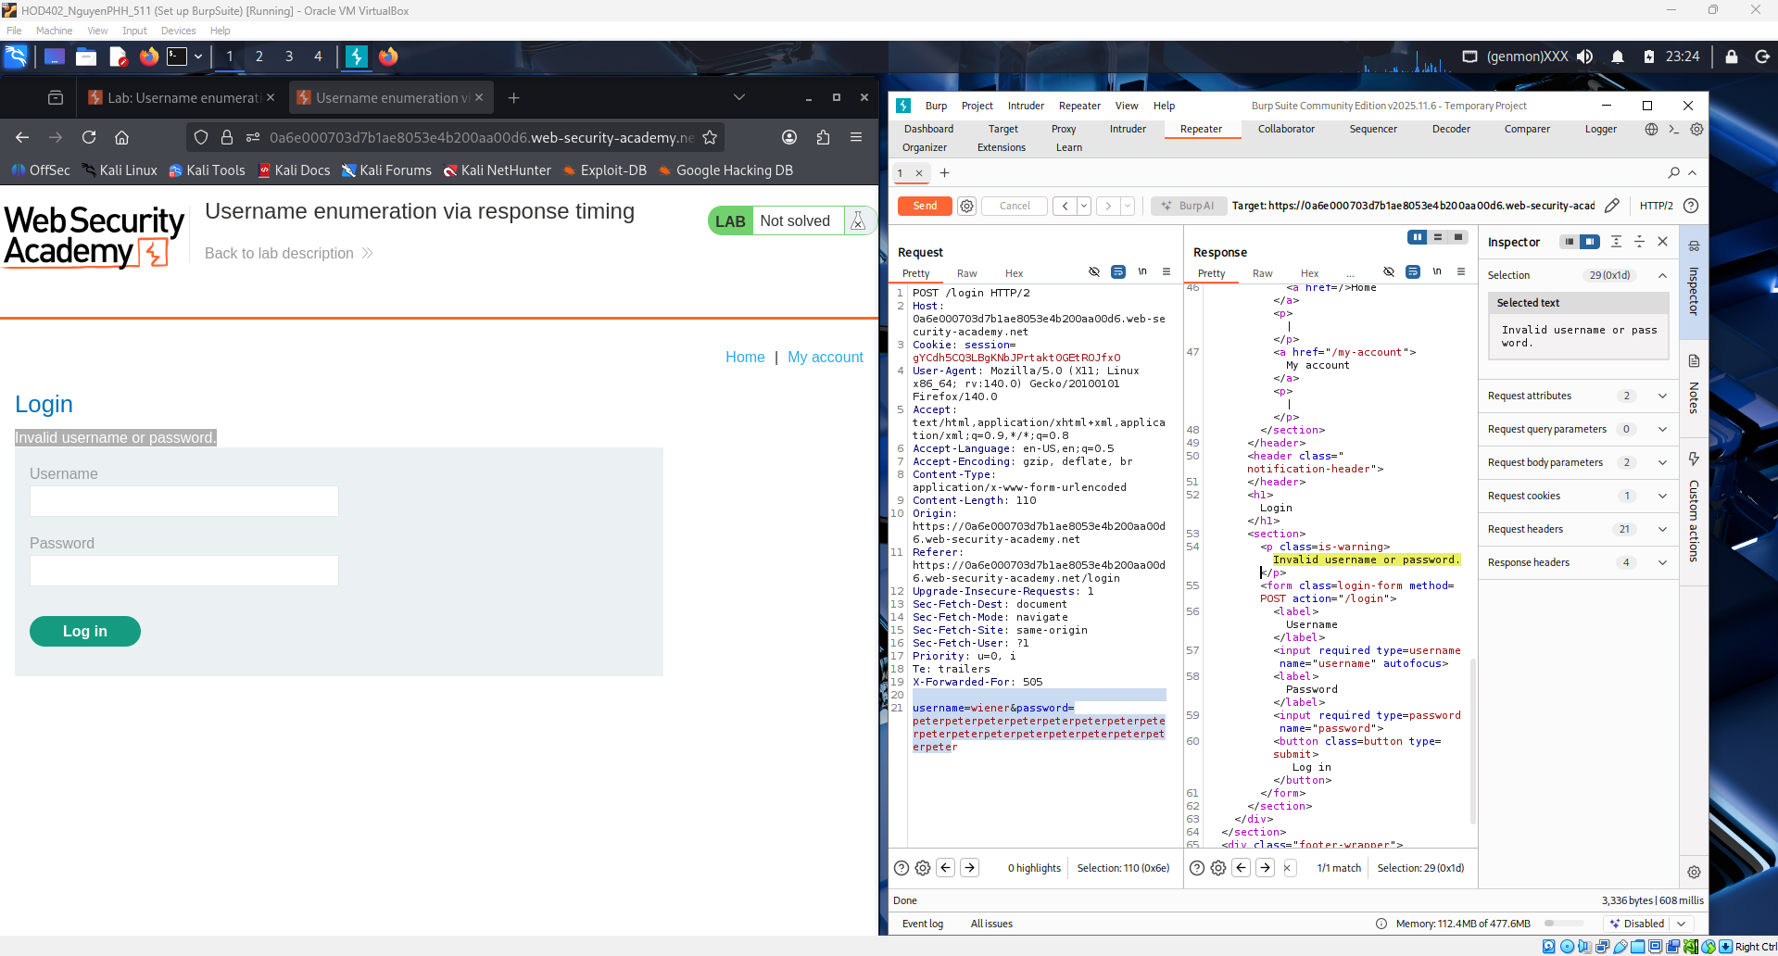
Shows Burp Intruder configured to attack the login request. The username parameter is set as the payload position, and a list of possible usernames (from the lab-provided list) is loaded under the Payloads tab. A very long password is used to amplify processing time, allowing the attacker to detect valid usernames by comparing response time differences during the attack.
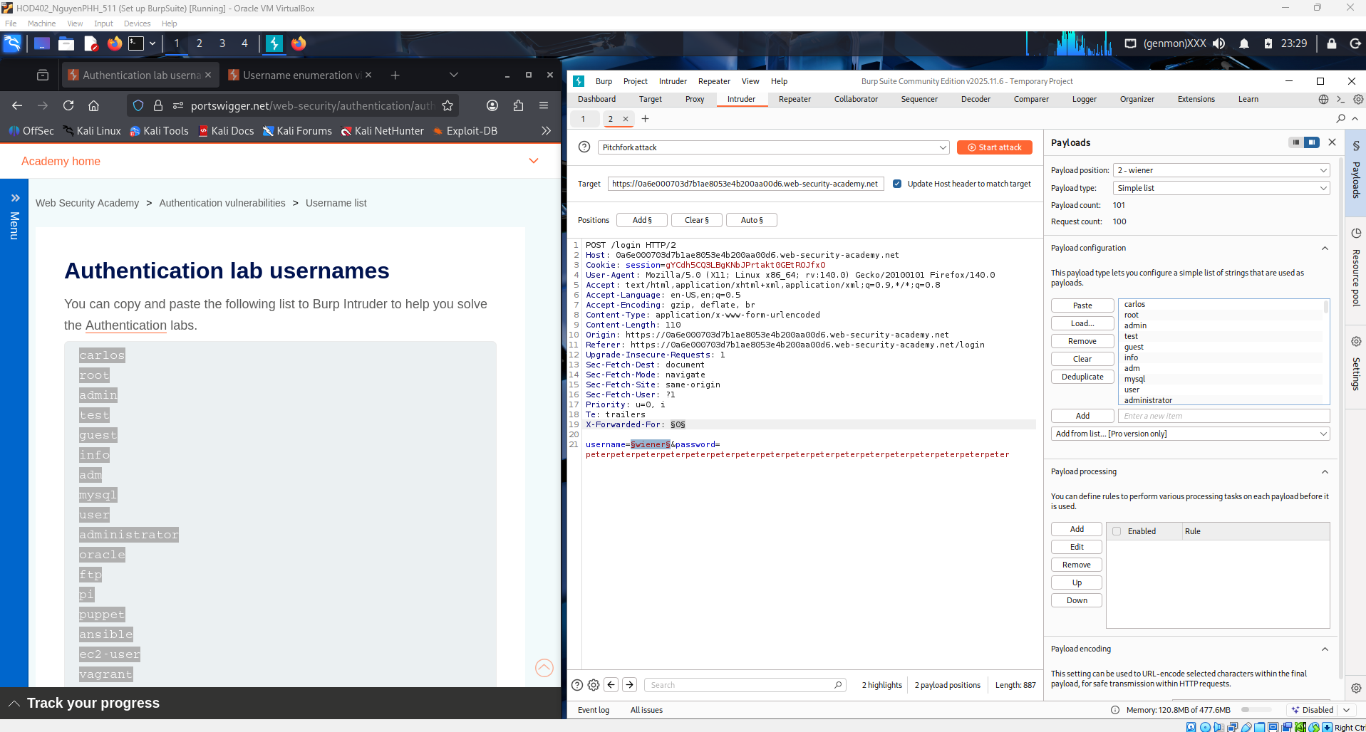
Shows the Burp Intruder attack results after sending multiple login requests with different usernames. The Status code and Response length are similar, but one request stands out with a noticeably higher response time, indicating the server spent longer processing it. This delay happens because the username is valid, and the server performs password verification, confirming successful username enumeration via response timing.
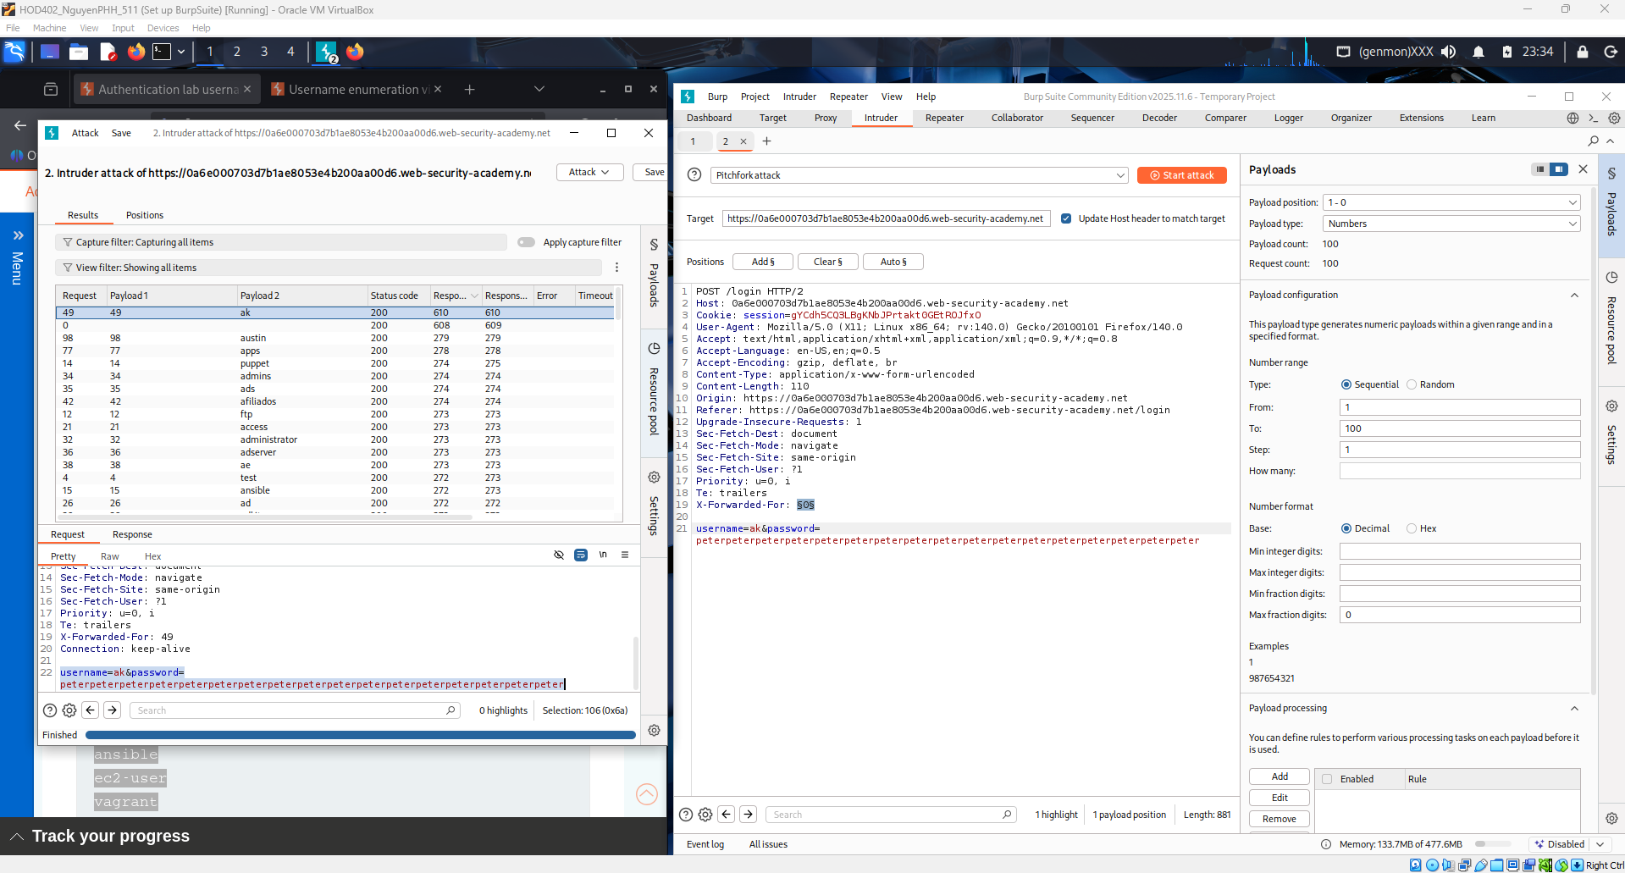
Shows Burp Intruder configured again, but this time the password parameter is set as the payload position. A password wordlist provided by the PortSwigger lab is loaded to test multiple passwords against the valid username discovered earlier. The attack will identify the correct password based on a different server response, such as a redirect or successful login.
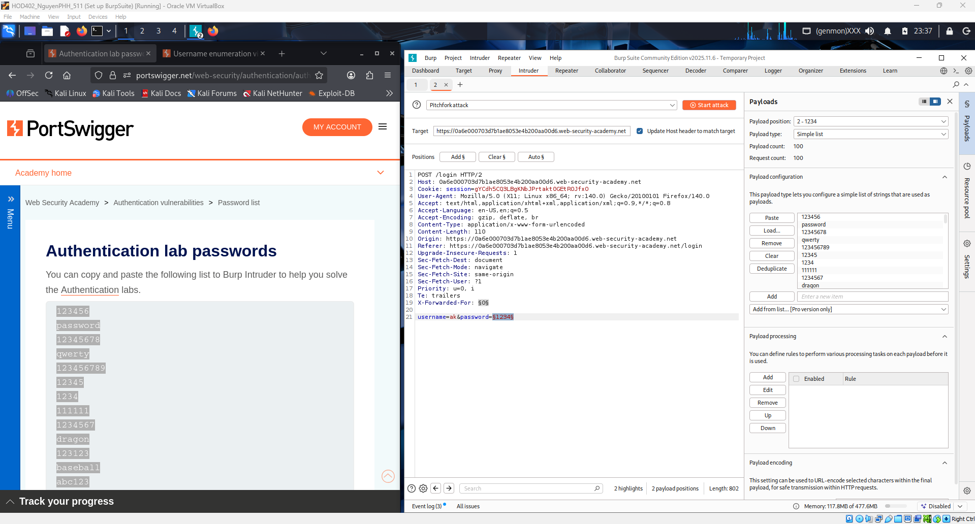
This screenshot shows the Burp Intruder results for the password brute-force attack. Most responses return Status 200 with similar response lengths, indicating failed logins. However, one request stands out with Status code 302, which means the server redirected after a successful login — confirming this payload is the correct password.
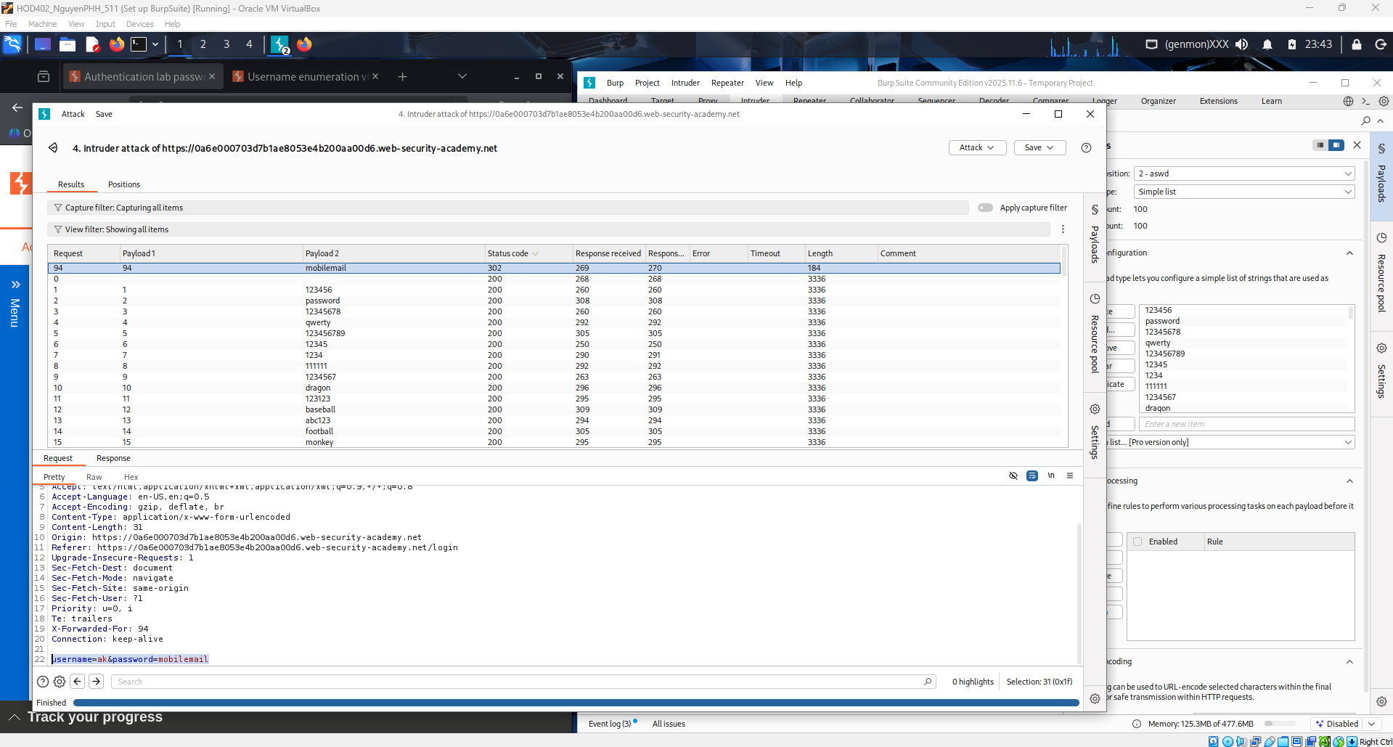
Shows the Web Security Academy page displaying the message “Congratulations, you solved the lab!”, confirming successful exploitation. The attacker logged into the account after identifying a valid username through response timing and discovering the correct password using brute-force. The “My Account” page proves authentication was bypassed successfully.
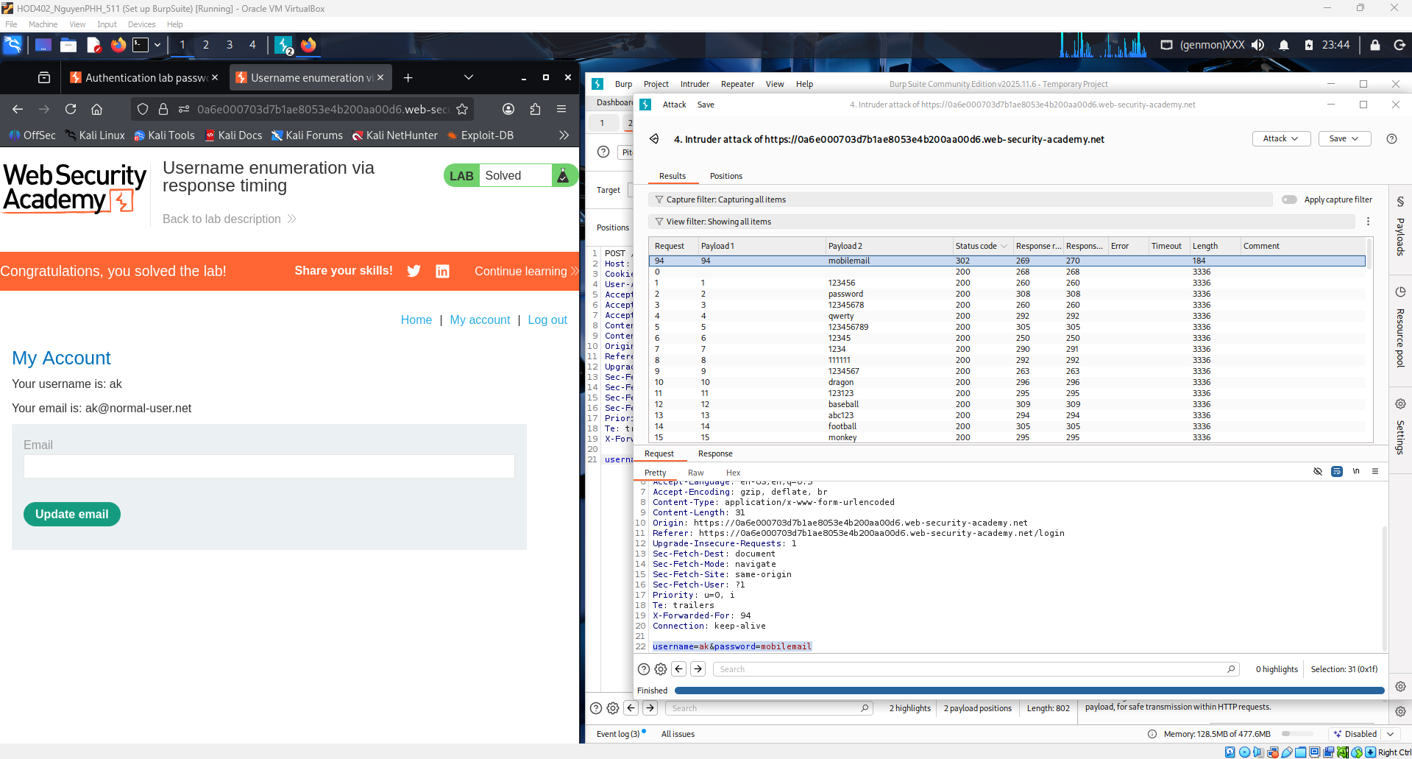
Conclusion:
This lab demonstrates how a login system can leak sensitive information through response timing differences. By sending multiple login requests and analyzing server response times in Burp Suite, it was possible to identify a valid username even though the error messages were identical. After discovering the correct username, a brute-force attack was used to find the correct password, leading to successful account access.
The vulnerability exists because the server processes valid usernames differently from invalid ones, causing measurable timing variations. This shows that even when visible responses are generic, side-channel information like timing can still expose authentication data. Proper mitigation includes using constant-time responses, implementing rate limiting, and adding account lockout or CAPTCHA mechanisms to prevent automated attacks.

